Global Warming

Pre reading questions
Before reading |  |  | After Reading
True | False |  | True | False
  |   | The earth’s surface temperature is more than 5 degrees Fahrenheit warmer than it was a century ago. |  |  
 |   | Global warming is well understood. |   | 
  |   | Extra Carbon Dioxide is the main greenhouse gas that has caused recent global warming. |   | 
  |   | Greenhouse gases come from using oil, gas and coal. |   |  
  |   | The United States produces 1/5 of the world’s human-made greenhouse gases. |   |  
  |  | There are clear ways to reduce or stop global warming. |  |  

After the reading, in addition to marking the statements true or false correct the statements that are false.
Causes
Production of Greenhouse gases and Global Warming
Effects

Fill as many lines as possible with causes and effects. Feel free to add more lines.
Homework

Over the long weekend do further research on global warming. Use the internet or go to your local library, where they will have encyclopedias and other reference books.

The information you gather will be used in class on Monday.

Fill the space below with information about global warming. The information could be data, diagrams or texts. The information could be about the whole world or about how it affects you. The information could be written by hand or glued in.

Check the box that you think your information best fits.

- Manmade sources of greenhouse gases | - How global warming works | - Natural Sources of greenhouse gases | - Results of global warming
- Laws about global warming | - History of global warming | - Your personal contribution to global warming. | - Ways to reduce global warming

Sources for your information: _______________________________________________ ________________________________________________________________________
________________________________________________________________________

An Introduction
According to the National Academy of Sciences, the Earth's surface temperature has risen by about 1 degree Fahrenheit in the past century, with accelerated warming during the past two decades. There is new and stronger evidence that most of the warming over the last 50 years is due to human activities. Human activities have changed the chemical composition of the atmosphere through the buildup of greenhouse gases – primarily carbon dioxide, methane, and nitrous oxide. The heat-trapping property of these gases is undisputed although uncertainties exist about exactly how earth’s climate responds to them.

Our Changing Atmosphere
Energy from the sun drives the earth’s weather and climate, and heats the earth’s surface; in turn, the earth radiates energy back into space. Atmospheric greenhouse gases (water vapor, carbon dioxide, and other gases) trap some of the outgoing energy, retaining heat somewhat like the glass panels of a greenhouse.
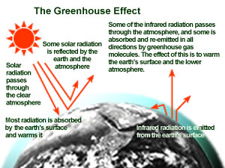
Without this natural “greenhouse effect,” temperatures would be much lower than they are now, and life as known today would not be possible. Instead, thanks to greenhouse gases, the earth’s average temperature is a more hospitable 60°F. However, problems may arise when the atmospheric concentration of greenhouse gases increases.

Since the beginning of the industrial revolution, atmospheric concentrations of carbon dioxide have increased nearly 30%, methane concentrations have more than doubled, and nitrous oxide concentrations have risen by about 15%. These increases have added to the heat-trapping capability of the earth’s atmosphere.
Why are greenhouse gas concentrations increasing? Scientists generally believe that the combustion of fossil fuels and other human activities are the primary reason for the increased concentration of carbon dioxide. Plant respiration and the decomposition of organic matter release more than 10 times the CO2 released by human activities; but these releases have generally been in balance during the centuries leading up to the industrial revolution with carbon dioxide absorbed by the earth’s plants and the oceans.
What has changed in the last few hundred years is the additional release of carbon dioxide by human activities. Fossil fuels burned to run cars and trucks, heat homes and businesses, and power factories are responsible for about 98% of U.S. carbon dioxide emissions, 24% of methane emissions, and 18% of nitrous oxide emissions. Increased agriculture, deforestation, landfills, industrial production, and mining also add a significant share of emissions. In 1997, the United States emitted about one-fifth of total global greenhouse gases.
Estimating future emissions is difficult, because it depends on demographic, economic, technological, policy, and institutional developments. Several emissions scenarios have been developed based on differing projections of these underlying factors. For example, by 2100, in the absence of emissions control policies, carbon dioxide concentrations are projected to be 30-150% higher than today’s levels.

Changing Climate
Global average surface temperatures have increased 0.5-1.0°F since the late 19th century. The 20th century's 10 warmest years all occurred in the last 15 years of the century. Of these, 1998 was the warmest year on record. The snow cover in the Northern Hemisphere and floating ice in the Arctic Ocean has decreased. Globally, sea level has risen 4-8 inches over the past century. Worldwide precipitation over land has increased by about one percent. The frequency of extreme rainfall events has increased throughout much of the United States.
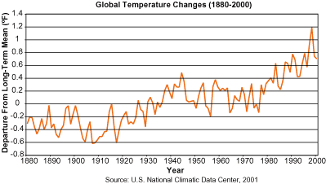
Increasing concentrations of greenhouse gases are likely to accelerate the rate of climate change. Scientists expect that the average global surface temperature could rise 1-4.5°F (0.6-2.5°C) in the next fifty years, and 2.2-10°F (1.4-5.8°C) in the next century, with significant regional variation. Evaporation will increase as the climate warms, which will increase average global precipitation. Soil moisture is likely to decline in many regions, and intense rainstorms are likely to become more frequent. Sea level is likely to rise two feet along most of the U.S. coast.
Calculations of climate change for specific areas are much less reliable than global ones, and it is unclear whether regional climate will become more variable.

