Acceleration of Falling Objects

Ball dropped from ceiling
Prediction – light line
Actual softball – dark line
Actual basketball – dark dotted line

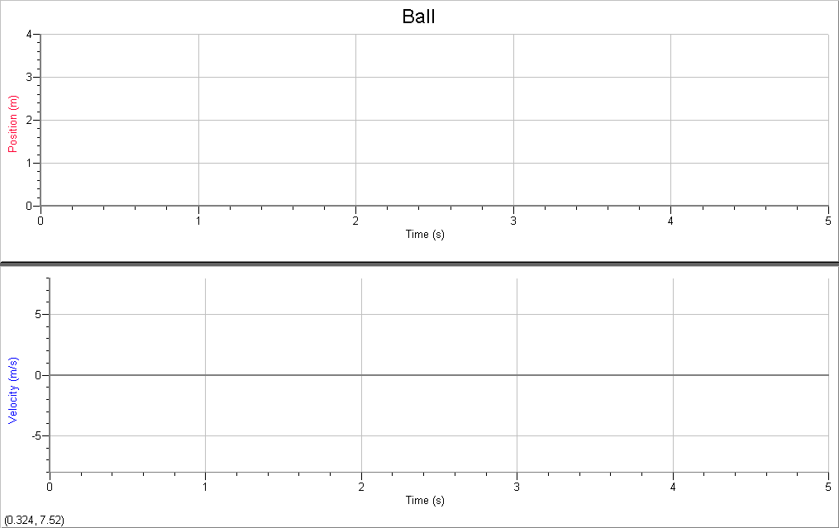

Falling ball story:
When the ball falls it starts off at 0 m/s because it is simply dropped and not thrown

down. It keeps getting faster and faster for about ______________.As it falls it gains

speed at a _____________________ of _________. This means that the acceleration

due to gravity is________________.

Part II

Ball thrown down from ceiling
Saved dropped ball line – dashed
Predicted thrown ball line – light line
Actual thrown ball line – dark line

Thrown ball story:

This time the ball’s velocity starts out increasing at a ____________________ rate, but

Part III

Ball dropped onto motion detector

Prediction - light lines
Actual drop – dark lines

Ball Story

This time as the ball is dropped the velocity starts at__________________

and . . .

Part IV

Tossing the Ball Up

Saved falling ball graph – dotted line
Prediction – light line
Actual graph - dark line

Ball story: (There’s a lot to talk about here. Make sure you tell the story of the ball while it is going up, at the moment it is at the top and one the way down. Refer to the graphs throughout.)

